

Helios Candles

Our Product

Helios is dedicated to providing our customers with a soothing and stress-relieving atmosphere. In order to achieve this, Helios candles are handmade using 100% soy wax, fragrance oils and essential oils to ensure our customers receive a product that is pleasant and relaxing in essence. Helios offers three different scented candles: violet, lemongrass and eucalyptus, all of which have unique benefits.

## Violet

Great for creating a romantic atmosphere for a special one, but don’t go thinking that you need a date to enjoy the sweet fragrance of our violet candles! With a delicate blend of jasmine petals, musk and spice, the fragrance of our violet candles helps set an energizing mood for happy thoughts which will ease feelings of nervousness and frustration. Light these violet candles to create an ambient setting in your house during a lonely and dark night all the while making you feel more comfy and cozy.

## Lemongrass

Say goodbye to sleepless nights and excruciating headaches! With a light, fresh, citrus smell with earthy undertones, our lemongrass candles will help you earn a goodnight’s sleep and reduce mind boggling headaches to a minimum. The scent of lemongrass provides a relaxing, soothing and balancing atmosphere, relieving you of any accumulated stress from a hard day of work or school. A yoga session will prove to be a lot more effective when our lemongrass candles set the mood. The fragrance diffuses around the room, taking you into a meditative state in a small period of time.

## Eucalyptus

With a minty and uplifting smell, our eucalyptus candles will provide relief from the sniffles as well as from irritating allergies. Also, whether it be a heavy load of schoolwork or a dull day of chores and mundane tasks, the scent emanated from this candle will help set your mind at ease, allowing you to address what needs to be done, preventing distraction from becoming your #1 enemy.

Our products are proudly made with the support and help of local suppliers. By doing so, we are limiting our ecological footprint while providing a high quality product that focuses on our customers’ well being.

Our customers’ satisfaction and health are of utmost importance to us and through our handmade candles, we guarantee that they will brighten up a rainy day and bring a new light into your world.

1 / 4



2 / 4



3 / 4

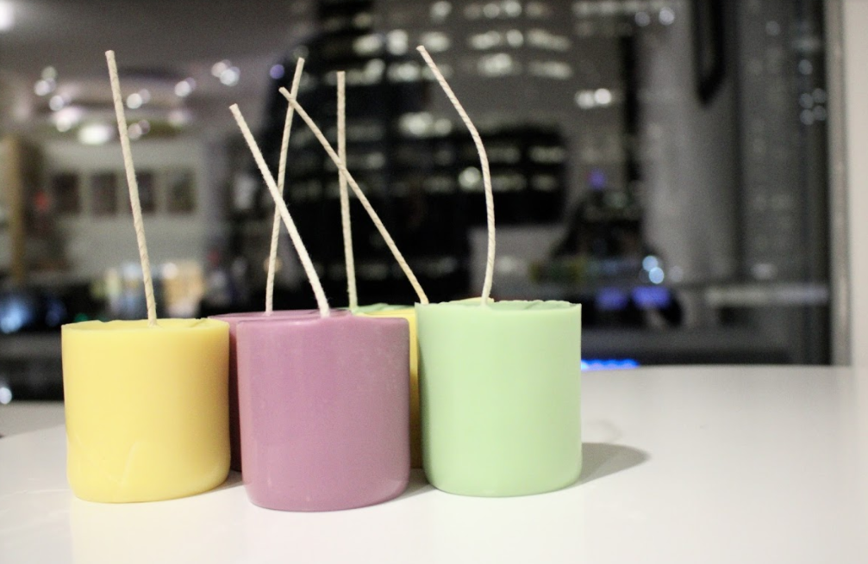

4 / 4

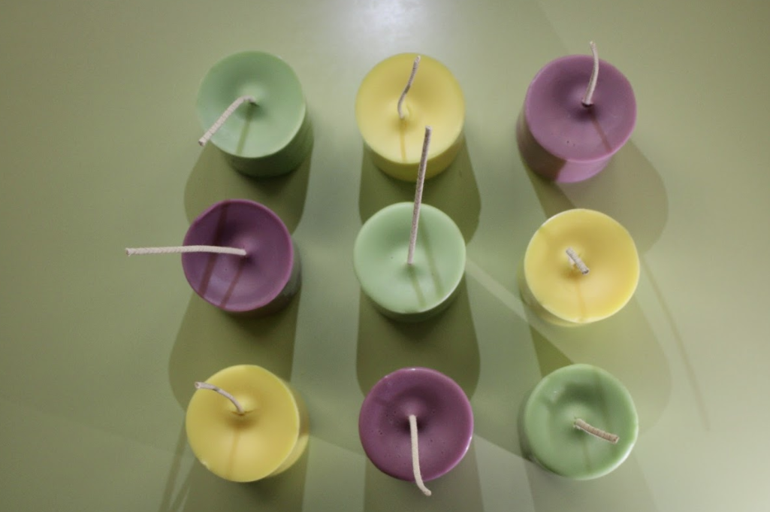❮ ❯

About Us

Helios is a Junior achivement company that meets every week at Deloitte in downtown Calgary.

We are a determined team to do well and succeed this year in the company program.

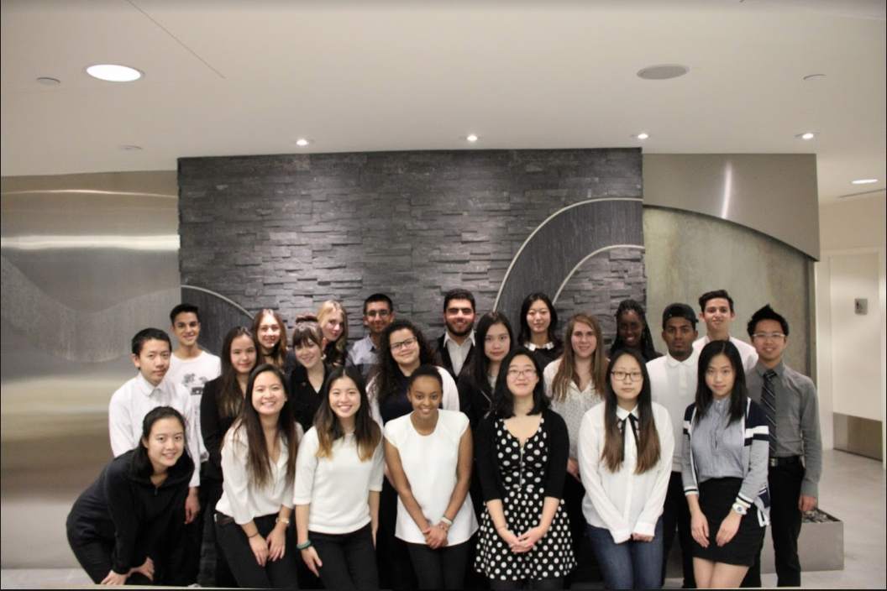

Our Charity

Helios Candles is donating 25% of all profits to "Light up the world".

Light up the world is a non-profit organization dedicated to provide lighting for people in areas in the world where they rely on it.

Contact us

[Email Us](mailto:ja.helioscandles@gmail.com)

 